|  |  |
| --- | --- |
| **Ivey Publishing Logo** | **National University of Singapore Logo** |

**9B21D010**

SALADSTOP!: refreshing the service delivery

Sheryl E. Kimes, Thompson S. H. Teo, and Iswarya Loganathan wrote this case solely to provide material for class discussion. The authors do not intend to illustrate either effective or ineffective handling of a managerial situation. The authors may have disguised certain names and other identifying information to protect confidentiality.

This publication may not be transmitted, photocopied, digitized, or otherwise reproduced in any form or by any means without the permission of the copyright holder. Reproduction of this material is not covered under authorization by any reproduction rights organization. To order copies or request permission to reproduce materials, contact Ivey Publishing, Ivey Business School, Western University, London, Ontario, Canada, N6G 0N1; (t) 519.661.3208; (e) cases@ivey.ca; www.iveycases.com. Our goal is to publish materials of the highest quality; submit any errata to publishcases@ivey.ca. i1v2e5y5pubs

Copyright © 2021, National University of Singapore and Ivey Business School Foundation Version: 2021-06-28

In May 2019, Adrien Desbaillets, the founder of SaladStop!, a Singapore-headquartered healthy salad chain with locations across Asia, was looking for innovative ways to improve the customer experience at his stores worldwide. In six months, Desbaillets was planning to renovate one of his branches in Singapore, located at 1 George Street. This renovation would set a precedent for future outlets in terms of layout and design; as such, it was a major milestone and required much thought.

Desbaillets was convinced that SaladStop! had a lot to offer its customers. He felt that customer interactions were truly the key to bringing further success for the salad chain. However, he was also aware of rising customer dissatisfaction caused by some service quality issues. As such, Desbaillets urgently needed to find a way to maintain customer interactions at SaladStop! while paying attention to customers’ expectations.

There were many questions that needed to be considered before the renovation could begin. However, the most pressing questions involved Desbaillets and his team’s long-term view of the salad chain. Should SaladStop! embrace new technologies in the restaurant business, or should it continue to focus on offering a truly authentic customer experience by relying on traditional human touchpoints?

SALADSTOP!

Background

In 2008, as a result of the financial crisis, Desbaillets faced retrenchment from his position in a hotel investment company in China, and he thus returned to Singapore. During this period, he realized that, in Singapore, expats like himself were “craving a good salad” and that nutritious yet affordable meals were a rare combination. Seeing the fast-paced lifestyles in Singapore, Desbaillets, together with his father, Daniel Desbaillets, decided to bring two vastly contrasting concepts together: healthy eating and fast food.[1] SaladStop! was conceived in 2009 with the motto Eat Wide Awake. As Desbaillets admitted, “Simply put, we want to change the way people think about their food.”[2]

The menu at SaladStop! spanned salads, wraps, and mixed-grain bowls, with many Asian-inspired options to cater to local taste buds. These included signatures such as the Oh Crab Lah, based on Singapore’s chili crabs, and the Japanese-inspired Go Geisha, with soba noodles, edamame, and miso.[3] Apart from an emphasis on educating consumers about nutrition, SaladStop! was also committed to sourcing the best possible ingredients for its consumers by giving consideration to various aspects such as animal welfare, the food chain, and the environment.[4] SaladStop!’s ultimate goal was to become the world’s leading nutrition, health, and wellness company by serving tasty yet nutritious food.[5]

Since 2009, SaladStop! had experienced organic growth and currently had 15 stores in Singapore and many more overseas in the Philippines, Indonesia, Hong Kong, Malaysia, Vietnam, Korea, Japan, and Spain.[6] Further, the trend toward healthy eating was expected to spur further growth for the health-focused chain.

RECENT DEVELOPMENTS IN THE RESTAURANT INDUSTRY

A Rise in Online Food Deliveries

Online food delivery was expected to reach US$200 billion in revenues by 2025.[7] With the rise of food delivery platforms such as Uber Eats and GrabFood, consumers had begun to embrace the convenience of ordering food online.[8] These changing consumer behaviours could be either an opportunity or a threat to existing brick-and-mortar restaurants. Restaurants with a strong brick-and-mortar presence had greater potential to attract more consumers once they opened up their digital channels.[9] Meanwhile, restaurants that had been struggling to offer consumers delightful dining experiences were likely to face more competition from the greater accessibility offered by these online platforms. While many restaurants were tempted to begin expanding their digital touchpoints and honing their online strategies, it became clear that if they failed to preserve the quality of service at their physical outlets, they would risk losing the strongest avenue driving their brand awareness. Although engaging with consumers digitally was now key to achieving greater growth, restaurant operators had to also be mindful of the significance played by their traditional store formats in complementing their digital presence.

The Shift to Fast-Casual Dining

According to research conducted by Euromonitor International, fast-casual dining was the fastest growing segment across the restaurant industry in 2015, with a record growth rate of 10.4 per cent.[10] Consumers’ dining preferences were shifting toward more premium, yet casual, social experiences. Millennials, who were the dominant group in the world’s four largest economies of China, the United States, Japan, and Germany,[11] were increasingly opting for fast-casual options over fast food. Despite being strapped for time, they were not willing to sacrifice on quality and in fact sought out fresher ingredients, diverse cuisines, and unique experiences.[12] This meant that restaurants offering enhanced quality at affordable price points would likely see rising consumer demand.

**Increasing Labour Constraints**

The restaurant industry had always suffered from high employee turnover. The high-stress environment and low wages had earned the industry a poor reputation among its employees.[13] As such, restaurants were forced to recruit new employees to replace those who left. However, as tertiary education rose in the population, and as more youths moved into professional jobs, the restaurant industry was beginning to witness greater labour shortages.[14] Given that labour costs already formed a large component of expenses incurred by restaurants,[15] these labour shortages were expected to create further drags on the profitability of restaurant chains.

The George Street SALADSTOP! Store

Overview

The George Street store, located among numerous office buildings in the city centre, was the busiest SaladStop! outlet within Singapore. As with other branches located in Singapore, the store was open from 8:00 a.m. to 8:30 p.m. All Singapore branches were fully managed by SaladStop!, whereas branches located overseas were operated under a franchise model.

The George Street outlet would be the first of the many branches in Singapore that would undergo renovations. Given that the renovation of this outlet would set the standards for subsequent renovations of other local stores, there was an urgent need to identify the strengths and weaknesses of the existing store layout as well as the best means of improving upon the store layout to enhance key aspects of the customer experience currently enjoyed by SaladStop! patrons.

Customer Experience at the George Street Store

All SaladStop! outlets in Singapore offered customers three ways to order their meals. First, customers could opt for the traditional method of visiting the store and placing their orders directly at the salad bar counters. Second, if customers did not wish to wait in line, they could pre-order their meals, paying in advance via the SaladStop! application, and collect their meals at a pre-specified time. Last, if travelling to the stores was troublesome, customers could place their orders on any of the three large online food delivery platforms in Singapore (GrabFood, Foodpanda, and Deliveroo) and wait for their meals to be delivered to their doorsteps.

Across the three methods of ordering, most sales at the George Street outlet were generated from customers who purchased their meals in-store. These walk-in customers made up roughly 86 per cent of sales at the outlet (see Exhibit 1). These customers often chose to dine in at the outlet, but some customers opted for takeout. Takeout customers were primarily people who worked in the vicinity and visited the store during their lunch hours, between 12:00 p.m. and 2:00 p.m. There were also other casual diners who visited SaladStop! outside of these hours.

Since most walk-in customers arrived at the George Street store during the lunch hours, the store was usually crowded during this time. The queues often stretched from the salad bar and into the dining area of the store. Customers who joined the queue at the salad bar often had to wait approximately five minutes before reaching the front of the line. Once at the front, customers could either choose to order from the set menu or create their own meal. If they chose the latter, they could order either a salad, a wrap, or a grain bowl and then proceed to choose the seven standard toppings included in their meal. Although the menu did not explicitly mention the standard toppings available for selection, customers could examine all available toppings from across the glass panel of the salad bar and subsequently choose seven standard toppings. There was originally a total of 35 standard toppings from which customers could choose, but this was eventually reduced to seven toppings and standardized across all markets. Premium toppings could also be added, but these cost extra. Once the customers had picked their toppings, they received order slips, which they needed to pass to the cashier. After payment was made at the cashier, customers returned to the collection point at the end of the salad bar to collect their meals. If their meals were not ready, they waited until the “salad artist” called out their order.[16]

Since SaladStop! also offered a set menu, those customers who did not require customized toppings could simply order from the available set menu items and immediately receive an order slip without having to pick any toppings from across the salad bar’s glass panels. This saved the customer time, as they proceeded to the cashier to pay and then waited for their order to be called out.

In contrast to the walk-in customers, those who ordered their meals online received a different experience. Customers who ordered via the SaladStop! application arrived at the store only at their pre-specified time. Once they arrived, they usually did not need to wait too long because their food would be prepared slightly in advance of their arrival, packed in containers, and placed on the online pickup shelf. The shelf contained alphabetical labels that allowed customers to identify their orders based on the first letter of their last name. If they were still unable to find their orders, they could simply look at the order sheet attached to the order to identify the correct one. However, this was rarely necessary, as there were seldom more than two or three pre-orders on the shelf at any given point in time. As such, SaladStop! pre-order customers rarely faced difficulties in identifying their orders.

Those customers who ordered via one of the three delivery platforms did not need to set foot in the store. Instead, a delivery person from the corresponding company collected the appropriate order from the outlet’s online pickup shelf. Each section of the shelf was dedicated to a specific delivery platform, allowing delivery personnel to quickly identify the right orders. If the delivery personnel were still unable to find the right orders, they, too, simply needed to examine the order sheets.

CURRENT FORMAT of George Street Store

Overall Store Layout

The George Street store had a semicircular floor layout and was completely air-conditioned. When entering the store, customers would first see the cashier, followed by the salad bar, which was located to the right of the cashier. The online pickup shelf was also located between these two areas. Beside the cashier was a refrigerator labelled “Grab and Go,” from which customers could choose quick snacks and beverages to purchase. The kitchen was in the far-right corner of the store, separated by a wall. Meanwhile, the seating area was located directly in front of the salad bar (see Exhibit 2).

**Cashier**

At the cashier were menu boards and hanging signs that informed customers about the different breakfast offers and beverages available for purchase (see Exhibit 3). The grab-and-go fridge was also beside the cashier, which allowed customers who were in a rush to quickly grab a snack and pay for it. Cutlery was offered at the cashier as well. At the rightmost wall of the cashier were a few electronic tablets that allowed the cashier to handle online delivery orders received from the three delivery platforms. These tablets rang whenever a new order was made through one of these platforms. The cashier would accept the orders and print out the order slips, which were then passed to the salad artists at the salad bar.

Online Pickup Shelf

All online orders, which included orders from SaladStop!’s website as well as any orders made through the delivery platforms, were placed on the pickup shelf once prepared (see Exhibit 4). The first shelf was for orders made through the SaladStop! website; here, the alphabetical labels were designed to allow customers to find their orders based on the first letter of their last names. The second tier of the shelf was for orders made through one of the three delivery platforms; the labels on this tier corresponded to the three different delivery platforms. All shelves were at eye level. A bag stand was located beside the shelves. Since orders made through the SaladStop! website were not offered in plastic bags, the bags on the bag stand could be used by customers if needed. In addition, since cutlery was not provided for orders through the SaladStop! website, customers who required cutlery needed to obtain it from the cashier.

Salad Bar

The salad bar was where all walk-in customers went to place their orders (see Exhibit 5). Above the salad bar were many menu boards and hanging signs that displayed the different toppings and meal options available. These signs were not always apparent to customers and were often missed. Customers were separated from the salad artists by the glass panels of the salad bar, which allowed customers to see and select their toppings. All premium toppings were placed together at the end of the selection of toppings to ensure that customers were aware of the extra charges that would be incurred for these toppings.

Collection Point

The collection point located at the end of the salad bar was identified by a hanging sign that read “Pick Up Here” (see Exhibit 6). If needed, customers could use trays on the right side of the collection point to easily carry their meals. During the lunch period, the collection point was often filled with meals and sometimes extended across the salad bar’s length.

Seating Area

The seating area had a total of 50 chairs and 25 tables, which were arranged in two rows, directly in front of the salad bar. Whenever the queues became long, as they did during peak hours, the line at the salad bar extended between the tables and chairs and into the seating area. Due to the spatial constraints in the George Street store, the seats and tables were closely packed next to one another (see Exhibit 7). At the rightmost side of the seating area were sofas, positioned near the glass windows. These windows allowed natural sunlight to enter the store during the day.

Tray Return Area

The tray return area was located opposite the grab-and-go fridge—left of the store entrance and away from the seating area. Because of its location, customers often did not notice its presence. The tray return area also had bins dedicated for recyclables and general waste (see Exhibit 8). However, customers often did not separate their waste and instead left their trays on the shelves for the SaladStop! employees to clear.

SERVICE Quality Issues AT THE George Street STORE

Confusing and Disorderly Customer Flow

Although there was signage at the salad bar that stated, “Order Here,” many first-time customers entered the store and approached the cashier to place their orders, only to realize that they needed to order at the salad bar before they could make a payment. This was especially common during peak periods, when queues were formed at both the cashier and the salad bar, as it was difficult for first-time customers to discern the correct queue to join first. In addition, since the cashier was located directly in front of the store entrance, many new customers naturally gravitated to the cashier instead of the salad bar to place their orders. However, after their long wait, customers would reach the front of the line and be informed that they would have to wait in line at the salad bar instead. This caused much confusion for new customers who were unfamiliar with the customer process flow in SaladStop! stores.

Besides being confusing to new customers, the customer flow within the store was also disorderly during peak periods. As previously mentioned, customers who placed their orders at the salad bar would proceed to the cashier area to pay. Meanwhile, customers who had settled their bills at the cashier would walk toward the collection point at the end of the salad bar to collect their meals. This resulted in customers walking in opposing directions toward one another. During non-peak periods, this was often not an issue; however, during peak periods, the large number of customers moving to and fro resulted in congestion and disorder within the store. Furthermore, after customers collected their meals, they would head toward the seating area located in front of the salad bar. This led to these customers intersecting paths with those customers who were on their way to the cashier (see Exhibit 9). During peak periods, these customers would face more frustration, as the intersecting paths resulted in undue confusion, disorderly customer flow, and discomfort.

Long Waiting Times during the Lunch Period

Another issue at the George Street store was that, during the lunch period, there was high demand for both online and off-line orders. To cope with this higher level of demand, SaladStop! employed extra employees during peak periods. However, although more staff were available to pick the toppings chosen by customers, there was still only one employee assigned to the chopping station, which was where all the base vegetables as well as proteins picked by the customers were chopped before being mixed with the remaining toppings. This was because the chopping station had only one chopping block. As a result, bowls corresponding to different customers’ orders would at times pile up before the chopping station. This led to long queues, as the build-up of these bowls prevented salad artists from taking the next orders from subsequent customers waiting in line. The receipt of online orders during peak periods was another source of delay. Online orders needed to be fulfilled before the specified collection time and were therefore prepared in between walk-in customers’ orders. Whenever online orders surged, in-store customers faced longer waiting times, as the salad artists had to shift between picking the appropriate toppings for online and orders and preparing walk-in orders.

High Variability in Quality

The George Street location also suffered from variations in service quality. During non-peak periods, staff engaged in light-hearted banter with customers; however, during peak periods, there was no time for such authentic interactions, as customers were often in a hurry and were focused on getting their orders and returning to their office jobs. Further, due to the high stress that resulted from the long queues during these periods, employees were more likely to make mistakes, and sometimes the salad artists used the wrong toppings in customers’ meals. During these times, the store also became noisy from the chatter of dine-in customers, and the store’s noise levels could deter other potential customers from entering the store. These variations in service quality made for inconsistent customer experiences across different customers and different times of the day.

OVERCOMING SERVICE FAILURES

The Founder’s Perspective

After analyzing the store environment and the service failures at the George Street outlet, Desbaillets and his team quickly identified the set-up of the salad bar production line as the one key area in need of improvement. Currently, the salad bar catered to both online and off-line customers. However, Desbaillets and his team strongly believed that this was causing major delays in the preparation of meals for walk-in customers, consequently reducing customer satisfaction. As such, they believed that there was a need to set up a separate salad bar production line for online orders. However, the team was aware of the spatial constraints within the store. In its current state, with only one salad bar, the store already made customers feel cramped; if an additional salad bar were added, the restaurant space would be reduced further, creating more discomfort for customers. The team wondered if there was any other way to introduce a second salad bar without compromising on the spaciousness of the store. One suggestion was to replace the existing one-sided salad bar with a two-sided salad bar, which would allow employees to be lined on both sides. However, Desbaillets felt that this concept was against SaladStop!’s core value of raising awareness about food; he felt that customers needed to see the toppings across a glass panel and choose them to truly feel connected to the food that they ate. He also believed that it was necessary for employees to interact with customers as they picked the food, as this created truly positive and authentic experiences. For these reasons, he disliked the idea that employees would pick the toppings according to an order sheet filled out by customers. It was clear that the team needed to find alternative proposals.

Through discussions with the team, Desbaillets admitted that the variability in service quality was necessary. He proposed that not all customers were the same and that a varied approach was necessary to cater to differing customer types. He observed that office workers were often in a rush and were therefore less interested in maintaining conversation with SaladStop!’s employees. These customers prioritized time and efficiency over authentic experiences. Hence, the only way to offer them a satisfactory service was to provide their meals in a timely fashion. On the other hand, there were other casual diners who enjoyed the daily banter with SaladStop! employees. These customers appreciated the extra attention they received and were delighted whenever the staff remembered their names or favourite toppings. Customer interaction opportunities were necessary to truly offer these customers a satisfactory experience. With two types of customers wanting two starkly different service experiences, SaladStop! needed to find a way to cater to both customer types—by providing either efficiency or authentic interactions, depending on the customer, or by finding the right balance between the two approaches.

The team had been aware of the constraints of the existing store layout and their effect on customer satisfaction and flow within the store. They had, in fact, discussed various store layouts but were yet to find a design that resulted in minimal confusion and discomfort among customers.

One option was to assign an employee as an in-store guide to offer help to confused customers. This would ensure that any confusion was immediately addressed and would not lead to any built-up frustration. However, the team felt this was a suboptimal solution, as it meant one less employee would be available for the preparation of meals. Given the high labour cost, it was also not justified to have one staff member dedicated to addressing confusion among customers. Desbaillets wondered if this employee could be assigned more roles to make the solution more feasible.

An alternative solution was to simplify the process of ordering. Currently, ordering had to be done first at the salad bar before payment at the cashier could be completed. This caused confusion among first-time customers. One proposal was to combine the ordering and payment functions into a single step. However, this posed a challenge because the price differed between orders depending on the choice of toppings selected by a customer. If a customer selected premium toppings, they would have to pay more compared to those who simply stuck to the range of standard toppings. Given that Desbaillets preferred that customers choose their toppings from the salad bar directly instead of via an order sheet, the order would only be realized at the salad bar. As such, if the two functions were to be combined, payment would have to proceed directly after. Would this be a feasible alternative to reduce customer confusion?

Physical Constraints and Further Considerations

While there were many possible solutions, the team was further constrained by the physical barriers in the George Street store. There were currently two large pillars in the store: one in the kitchen, the other between the cashier and the salad bar. The presence of these two pillars meant that the different store elements could not simply be rearranged; conversely, they had to be arranged around the pillars, as these pillars were fixed in place.

Besides these physical barriers, there were other considerations that needed attention. While the George Street store required creative solutions to overcome the spatial constraints, in other branches overseas, space was not a major concern. Similarly, in other countries, such as the Philippines, labour costs were not as high as in Singapore; hence, solutions relevant to the Singapore context would prove less expensive in other markets. These were some of the concerns that Desbaillets was wrestling with. Even if he did find the perfect store layout for the SaladStop! branches in Singapore, the store concept would not necessarily be applicable to the remaining franchised branches in other markets overseas. As Desbaillets and his team pondered these concerns, they turned their attention to the decisions at hand.

EXHIBIT 1: SALES AT SaladStop! George Street OUTLET BETWEEN APRIL AND JUNE 2019

Source: Created by the case authors based on company sources.

EXHIBIT 2: SIMPLIFIED LAYOUT OF THE SaladStop! George Street STORE

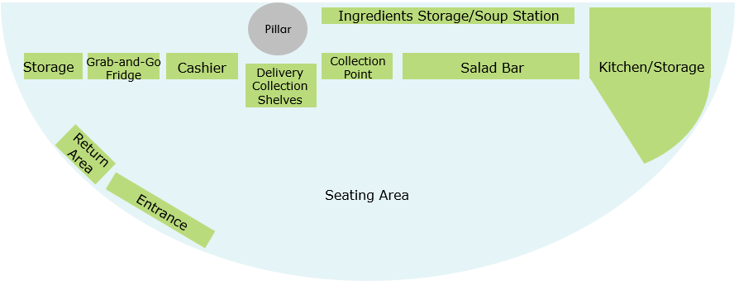

Source: Created by the case authors based on company sources.

EXHIBIT 3: CASHIER area AT THE SaladStop! George Street STORE

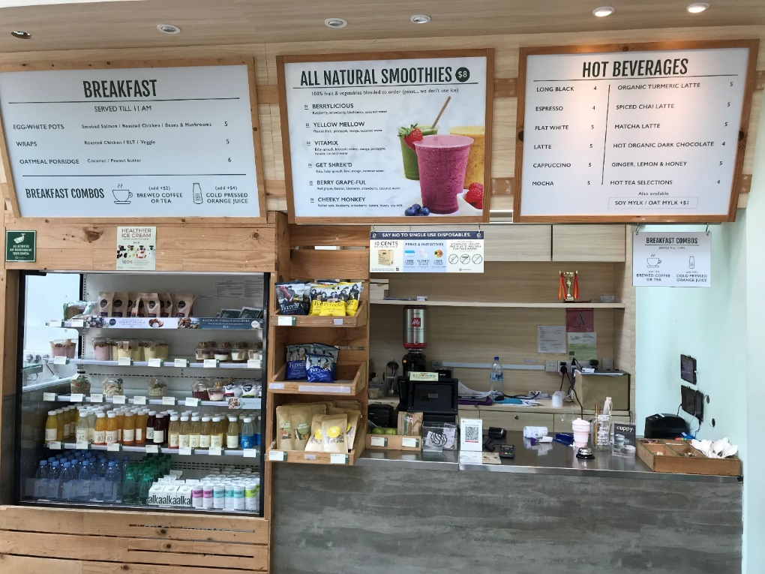

Source: Company sources.

EXHIBIT 4: ONLINE PICKUp SHELF at the SaladStop! George Street Store

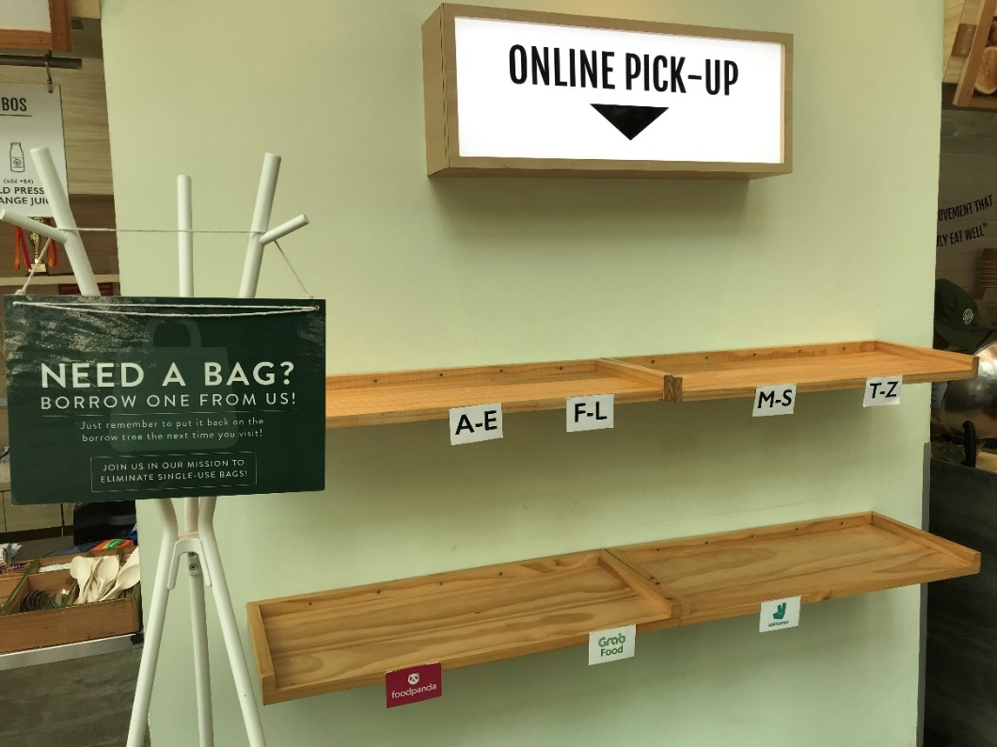

Source: Company sources.

EXHIBIT 5: SALAD BAR AT the SaladStop! George Street Store

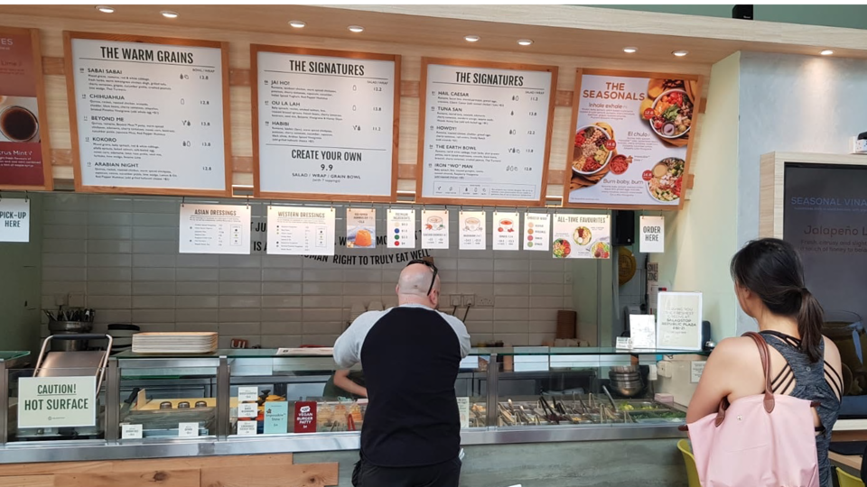

Source: Company sources.

EXHIBIT 6: COLLECTION POINT AT THE at the SaladStop! George Street Store

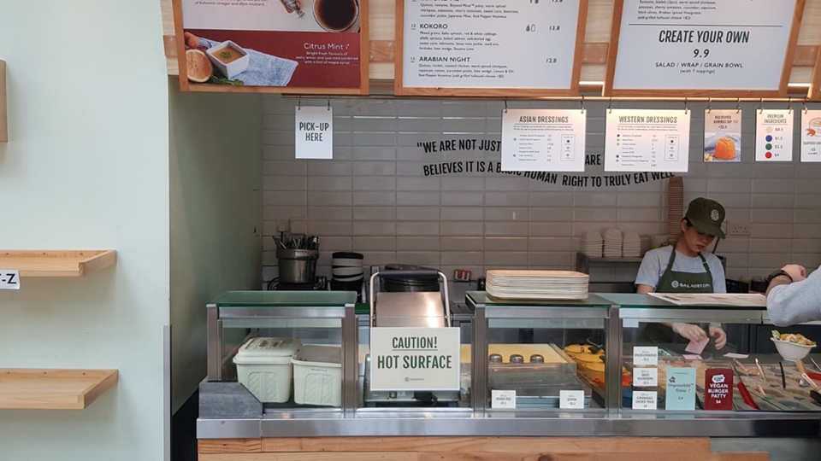

Source: Company sources.

EXHIBIT 7: SEATING AREA AT THE SaladStop! George Street Store

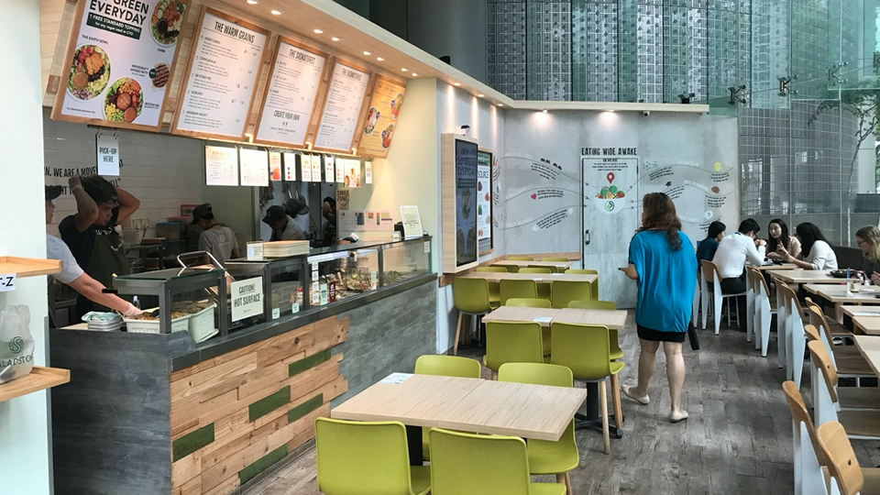

Source: Company sources.

EXHIBIT 8: TRAY RETURN AREA AT THE at the SaladStop! George Street Store

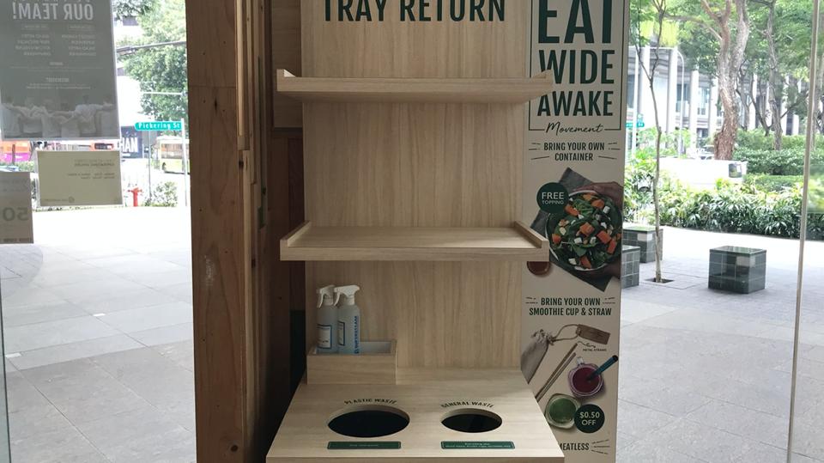

Source: Company sources.

EXHIBIT 9: CUSTOMER FLOW WITHIN the SaladStop! George Street Store

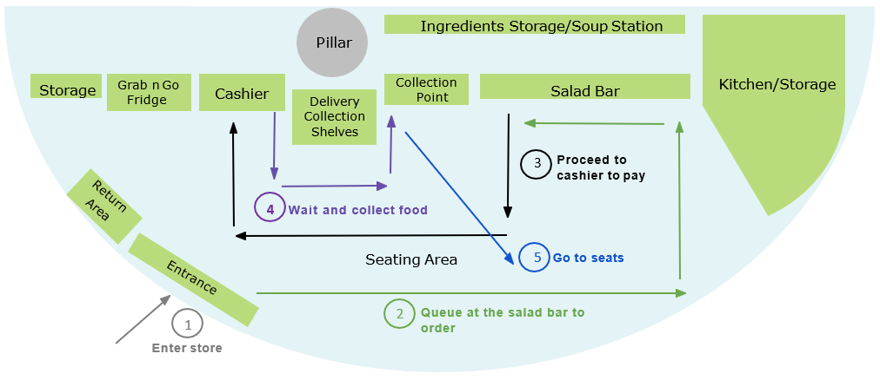

Source: Created by the case authors based on company sources.

1. “Adrien Desbaillets and Katherine Braha Desbaillets (SaladStop!),” StartupGrind, accessed May 2, 2020, https://www.meetup.com/Startup-Grind-Singapore/events/243169203/.
2. Stephen Jagger, “Restaurant Executive: Adrien Desbaillets, President SaladStop!,” Payroll Hero, June 1, 2015, accessed May 2, 2020, https://blog.payrollhero.com/2015/06/01/restaurant-executive-adrien-desbaillets-president-saladstop/.
3. “SaladStop! Malaysia, NU Sentral,” Eat Drink KL, August 21, 2019, accessed May 2, 2020, https://www.eatdrinkkl.com/posts/featured/saladstop-malaysia-nu-sentral.
4. Fiona Briggs, “Feeding Mind, Body and Soul,” *NACS Magazine*, June 2017, accessed May 2, 2020, https://www.nacsmagazine.com/issues/june-2017/feeding-mind-body-and-soul.
5. SaladStop! Singapore (website), accessed May 2, 2020, https://www.saladstop.com.sg/en/.
6. SaladStop! (website), accessed May 2, 2020, https://www.saladstop.com/.
7. Sarwant Singh, “The Soon to Be $200B Online Food Delivery Is Rapidly Changing the Global Food Industry,” *Forbes*, September 9, 2019, accessed May 2, 2020, https://www.forbes.com/sites/sarwantsingh/2019/09/09/the-soon-to-be-200b-online-food-delivery-is-rapidly-changing-the-global-food-industry/#5324478db1bc.
8. Hiba Amin, “10 Trends Shaping the Restaurant Industry in 2019,” ChefHero, March 21, 2019, accessed May 2, 2020, https://www.chefhero.com/blog/trends-shaping-the-restaurant-industry-in-2019.
9. Emma Liem Beckett, “6 Restaurant Trends That Could Turn Tables in 2019,” Restaurant Dive, January 7, 2019, accessed May 2, 2020, https://www.restaurantdive.com/news/6-restaurant-trends-that-could-turn-tables-in-2019-1/545323/.
10. “Fast Casual Is the Fastest Growing Foodservice Segment Globally,” *QSR Magazine*, April 20, 2016, accessed May 2, 2020, https://www.qsrmagazine.com/news/fast-casual-fastest-growing-foodservice-segment-globally.
11. Johnny Wood, “Generation Z Will Outnumber Millennials This Year,” World Economic Forum, August 23, 2018, accessed May 2, 2020, https://www.weforum.org/agenda/2018/08/generation-z-will-outnumber-millennials-by-2019/.
12. Chute Gerdeman, “The Rise of the Fast Casual Food Nation,” Chute Gerdeman, accessed May 2, 2020, https://www.chutegerdeman.com/the-rise-of-the-fast-casual-food-nation/.
13. Amanda McNamara, “How to Survive the Restaurant Industry Labor Shortage,” *On the Line*, accessed May 2, 2020, https://pos.toasttab.com/blog/on-the-line/how-to-handle-the-restaurant-industry-labor-shortage.
14. Alexia Fernández Campbell, “The US Is Experiencing a Widespread Worker Shortage. Here’s Why,” Vox, March 18, 2019, accessed May 2, 2020, https://www.vox.com/2019/3/18/18270916/labor-shortage-workers-us.
15. Mitchell Hall, “How to Efficiently Manage Labor Costs for Your Restaurant,” Restaurant Insider, September 5, 2018, accessed May 2, 2020, https://upserve.com/restaurant-insider/labor-cost-guidelines-restaurant/.
16. Employees who prepared the salads were referred to as “salad artists.”